Database assignment tables

Question 1: Show data of all the tables

CREATE TABLE Customers

(

CustomerID INT PRIMARY KEY,

FirstName VARCHAR(50) NOT NULL,

LastName VARCHAR(50) NOT NULL,

Email VARCHAR(20) NOT NULL UNIQUE,

Phone VARCHAR(11) NOT NULL UNIQUE,

JoinDate DATE NOT NULL

);

INSERT INTO Customers VALUES (1, 'Sanam', 'Ahmad', 'sanam@example.com', '03001234567', TO_DATE('23-AUG-2023', 'DD-MON-YYYY'))

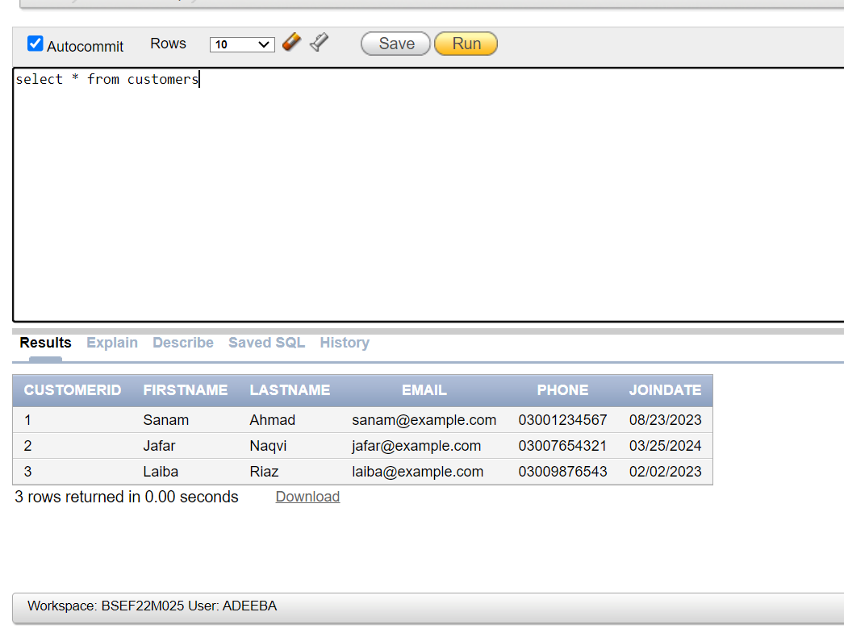

CREATE TABLE Categories

(

CategoryID INT PRIMARY KEY,

CategoryName VARCHAR(100) NOT NULL UNIQUE,

Description VARCHAR(200)

);

INSERT INTO Categories VALUES (1, 'Electronics', 'Electronic items like phones, laptops')

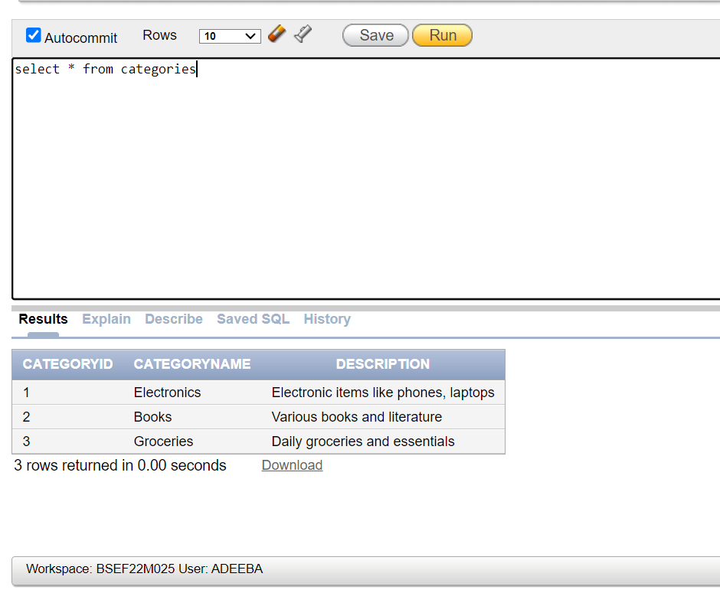

CREATE TABLE Products

(

ProductID int PRIMARY KEY,

ProductName VARCHAR(100) NOT NULL,

CategoryID int,

Price DECIMAL(10, 2) check (Price > 0),

StockQuantity INT check (StockQuantity >= 0),

FOREIGN KEY (CategoryID) REFERENCES Categories(CategoryID)

);

INSERT INTO Products VALUES (1, 'Smartphone', 1, 700.00, 50)

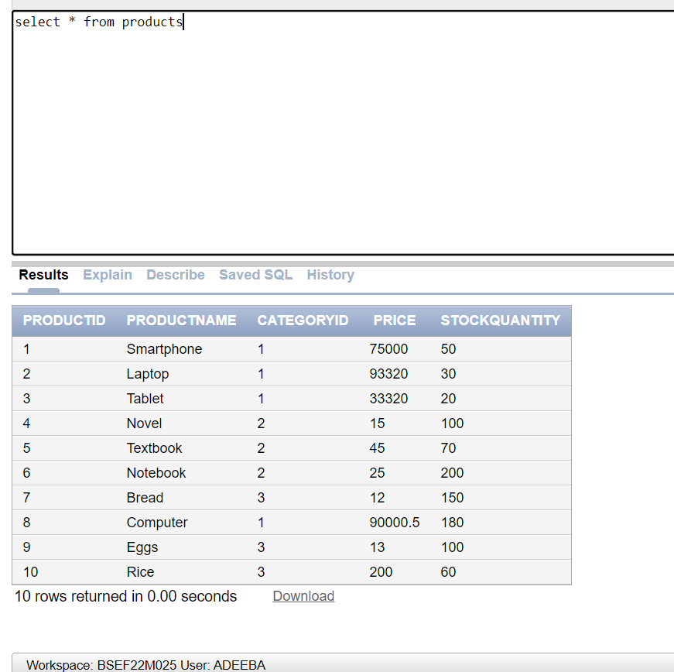

CREATE TABLE Orders

(

OrderID int PRIMARY KEY,

CustomerID int,

OrderDate DATE NOT NULL,

TotalAmount DECIMAL(10, 2) check (TotalAmount > 0),

FOREIGN KEY (CustomerID) REFERENCES Customers(CustomerID)

);

INSERT INTO Orders VALUES (1, 1, TO_DATE('01-AUG-2023', 'DD-MON-YYYY'), 1200.00)

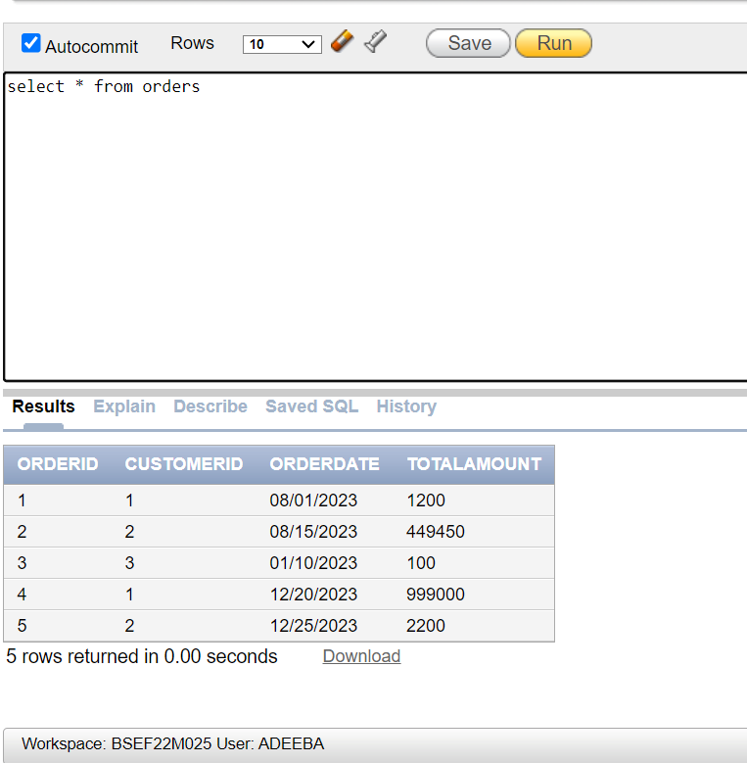

CREATE TABLE OrderDetails

(

OrderDetailID int PRIMARY KEY,

OrderID int,

ProductID int,

Quantity int check (Quantity > 0),

PriceAtOrder DECIMAL(10, 2) check (PriceAtOrder > 0),

FOREIGN KEY (OrderID) REFERENCES Orders(OrderID),

FOREIGN KEY (ProductID) REFERENCES Products(ProductID)

);

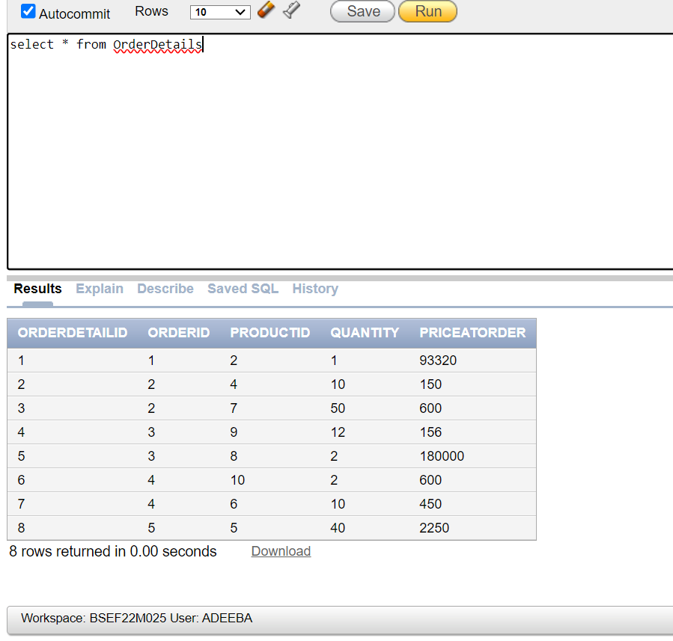

Question 2 Find the average price of all products in the 'Electronics' category

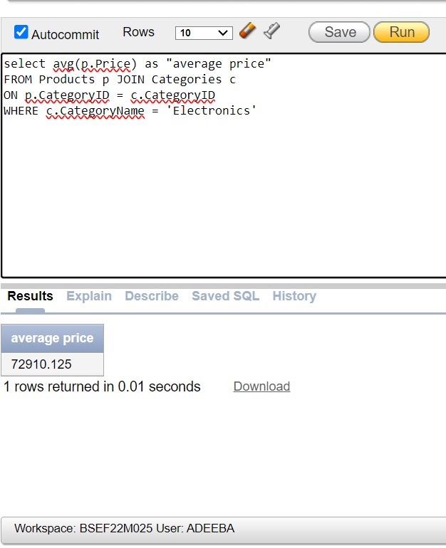

Question 3 Find the total revenue generated per customer, ordered by the highest revenue

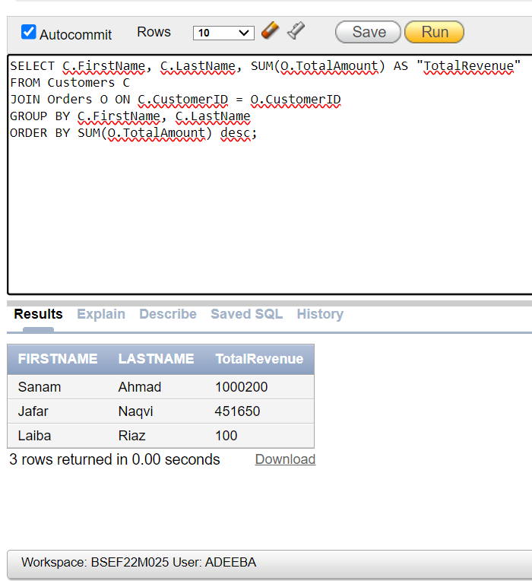

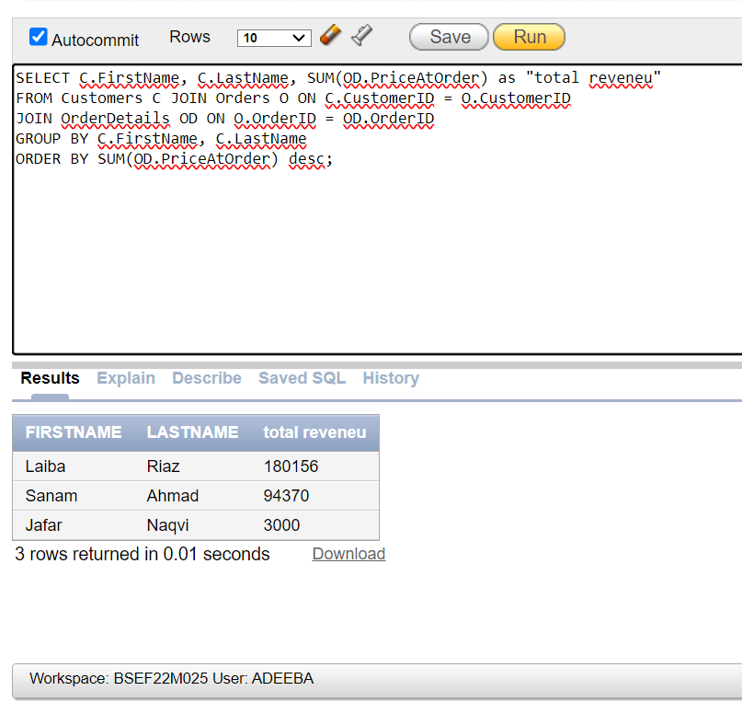

Question 4 Retrieve the FirstName, LastName, OrderDate, and TotalAmount for all orders placed by 'Sanam Ahmad'

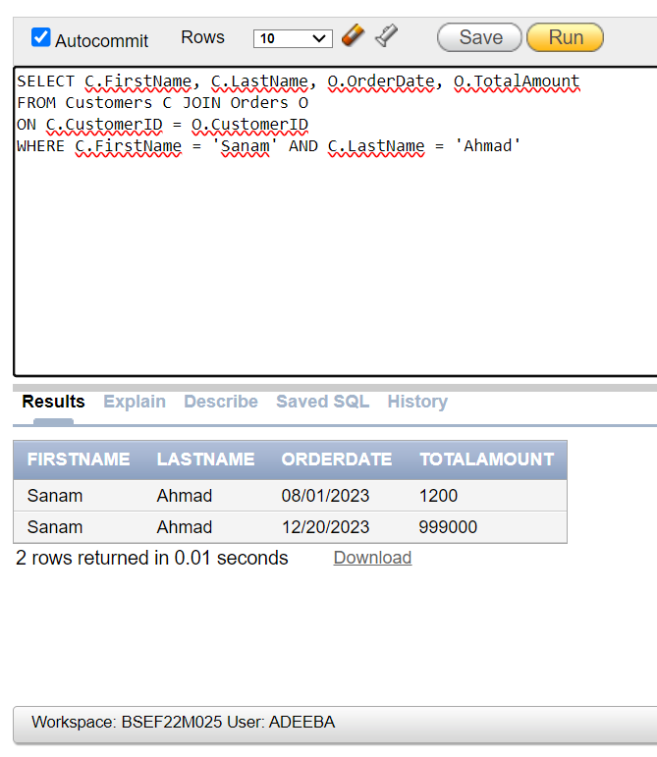

Question 5 Retrieve the total number of products sold in each category, ordered by the total number of products sold in descending order.

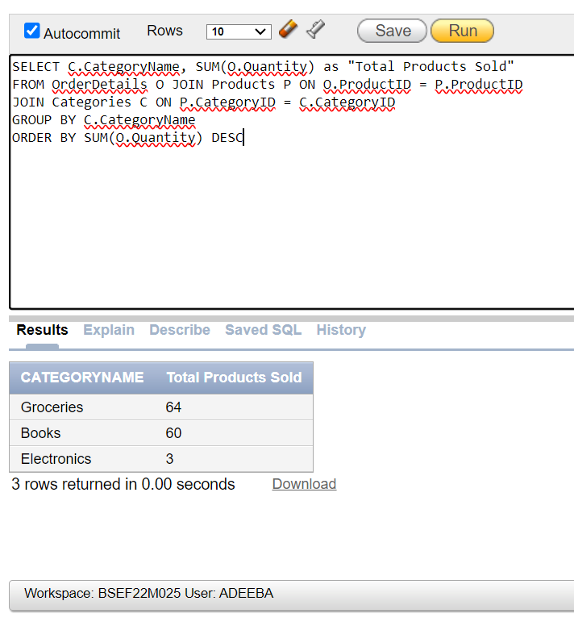

Question 6 (same as question 3) Find the total revenue generated per customer, ordered by the highest revenue.





Question 7 Retrieve the names of products ordered by customers who joined after March 1, 2023

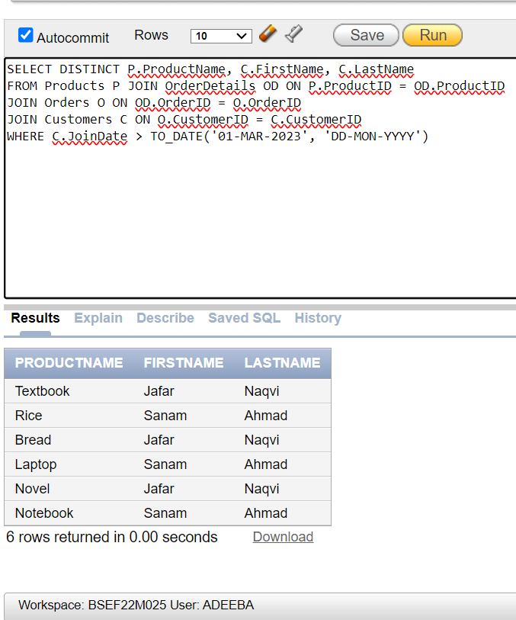

Question 8 Find the most expensive product in each category

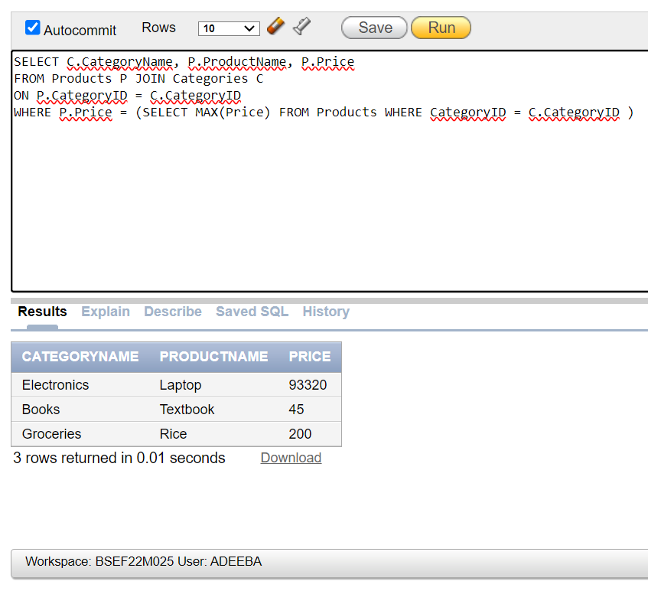

Question 9 Display the Total spent money of each Customer, Sort in ascending order

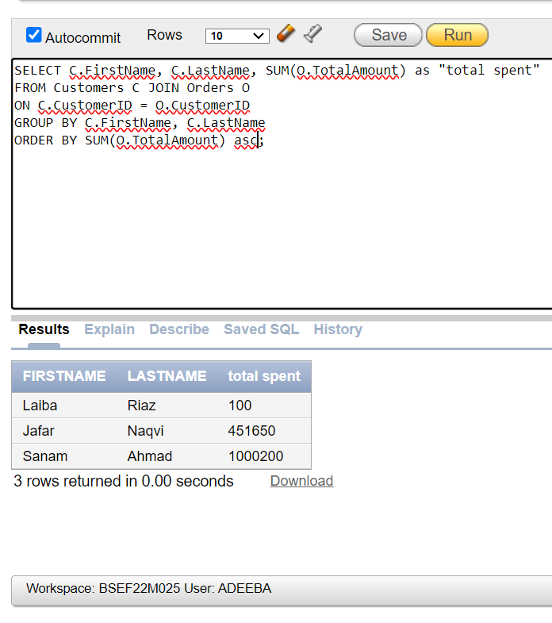

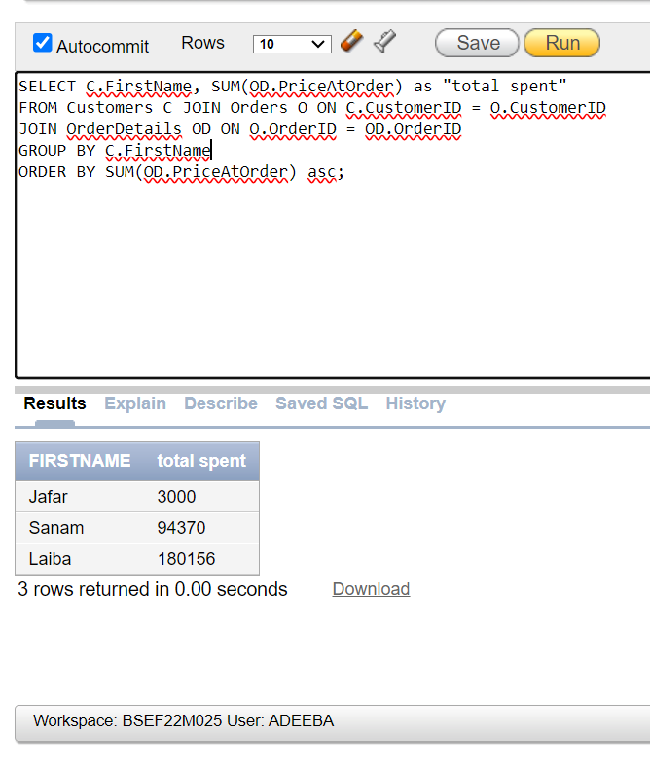

Question 10 Retrieve the total number of orders placed per month of year 2023

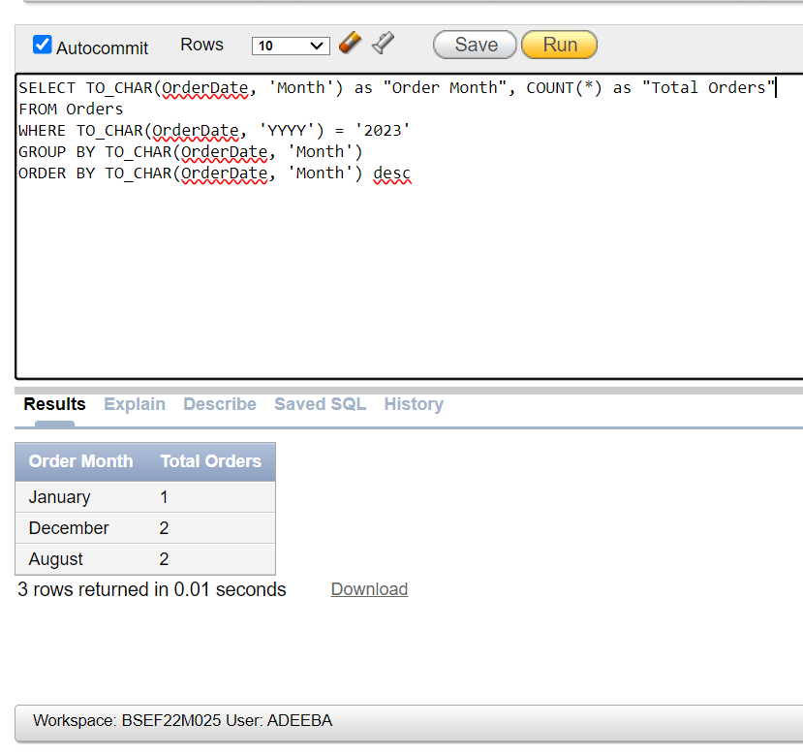

Question 11Find all products that have never been ordered.

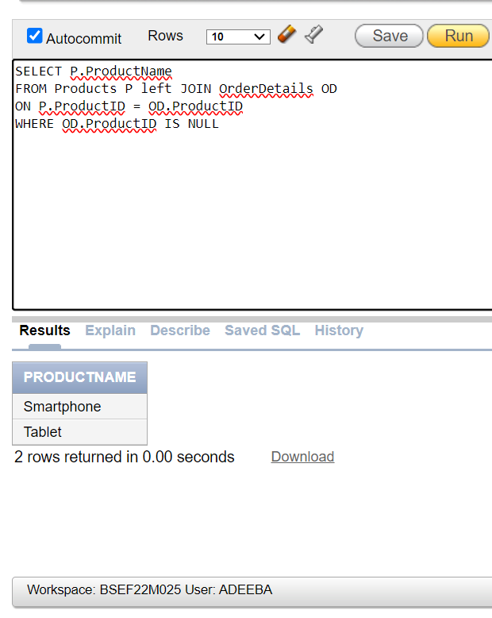

Question 12Find all customers who placed more than 3 orders.

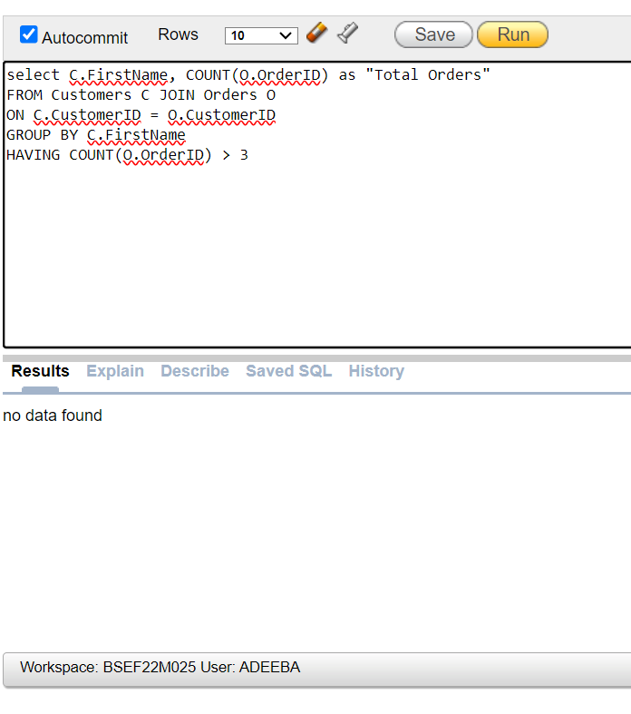

Question 13 List the categories that have more than 3 products

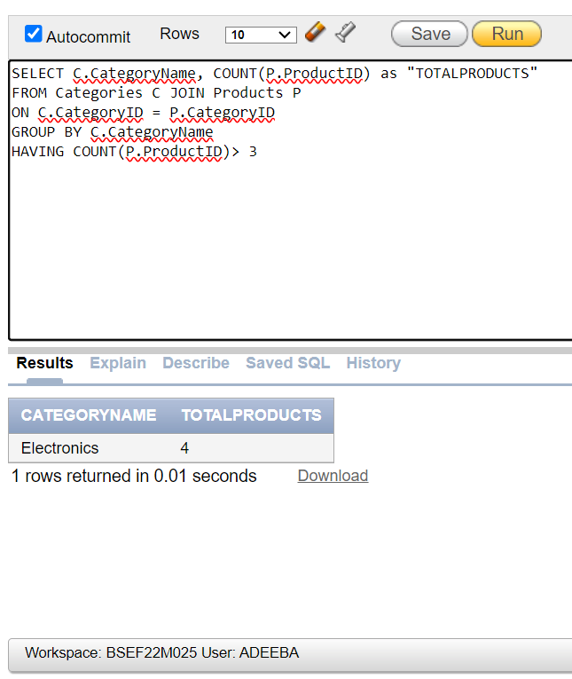

Question 14. Find the average, minimum, and maximum order total for each customer

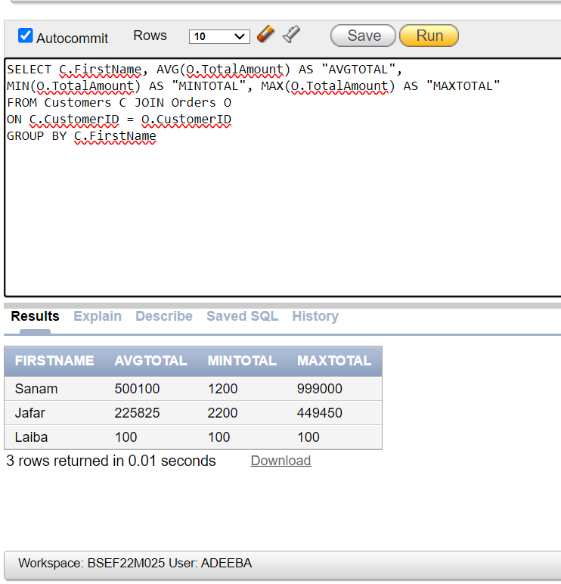

Question 15 Calculate the total revenue for each product and sort by highest revenue.

I didn’t multiply price at order with quantity for revenue because in table price at order is already the (price of one product * quantity).

